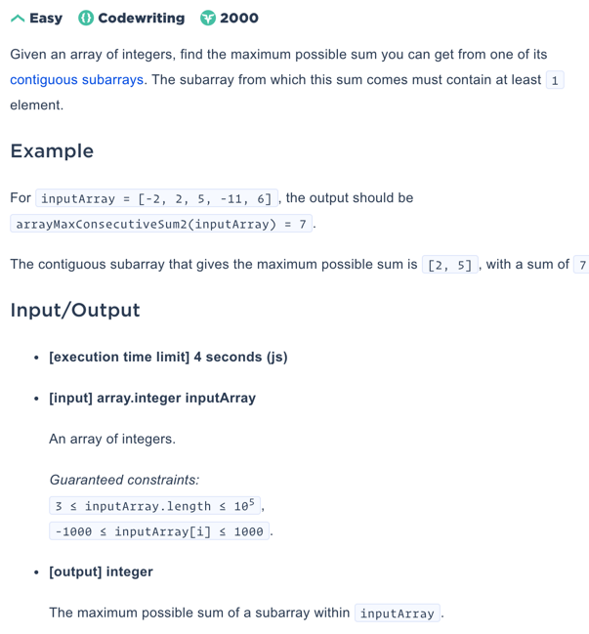

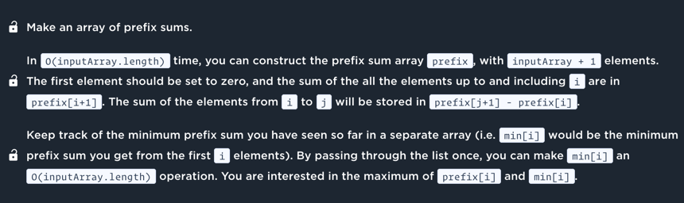

By josh72

function arrayMaxConsecutiveSum2(inputArray) {

let maxSum = inputArray[0];

let rollingSum = 0;

for (const current of inputArray) {

rollingSum = Math.max(current, rollingSum + current);

maxSum = Math.max(maxSum, rollingSum);

}

return maxSum;

}

By vasile_m1

function arrayMaxConsecutiveSum2(inputArray) {

let currentSum = 0,

currentMinimalSum = 0,

result = inputArray[0];

for (let i = 0; i < inputArray.length; i++) {

currentSum += inputArray[i];

if (currentSum - currentMinimalSum > result) {

result = currentSum - currentMinimalSum;

}

if (currentSum < currentMinimalSum) {

currentMinimalSum = currentSum;

}

}

return result;

}